

 Try DeFi – Using Uniswap or Aave Testnet  
  
**Objective/Aim:**  
In this lab, we are going to use the Aave protocol for a DeFi simulation. The objective is to understand the end-to-end workflow of a decentralized application by connecting a MetaMask wallet, operating on the Sepolia testnet, and executing a token swap in a secure, risk-free environment.  
  
  
  
  
  
  
**Apparatus/Software Used:**

* Laptop
* Brave with the MetaMask extension.
* MetaMask Wallet with Sepolia test ETH.
* The Aave decentralized application (app.aave.com).

**Theory/Concept:**

DeFi (Decentralized Finance): Financial applications built on blockchain technology that operate without central intermediaries like banks. Aave is a prime example of a DeFi lending and borrowing protocol.

Testnet: A replica of a main blockchain (like Ethereum) used for testing. Testnets, such as Sepolia, use tokens that have no real-world value, allowing users and developers to experiment without financial risk.

Token Swap: The process of exchanging one cryptocurrency for another through a liquidity pool. In this simulation, sepoliaETH is swapped for test DAI.

Price Impact: The effect that a trade has on the market price of the assets being traded. In pools with low liquidity (common on testnets), large trades can cause a significant price change, meaning you receive less of the destination token than expected.



**Procedure:**

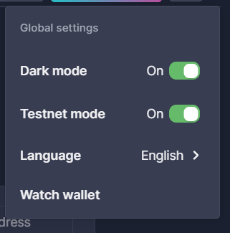Enable Testnet Mode: First, navigated to the Aave dApp settings and enabled "Testnet mode." This switched the interface from the main network markets to the testnet markets.

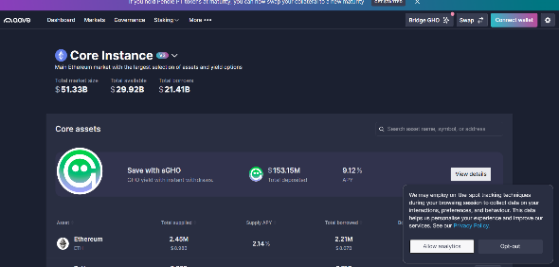

Clicked the "Connect wallet" button, selected MetaMask from the list, and approved the connection request from the wallet pop-up. This allows the Aave dApp to view the wallet's address and suggest transactions.

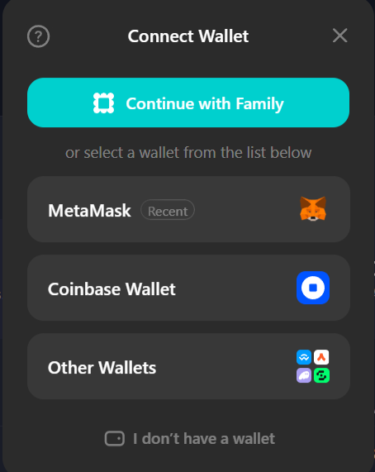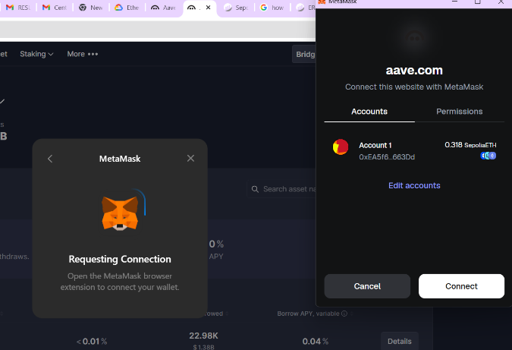

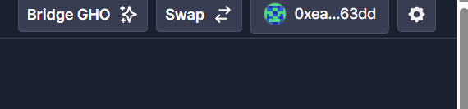Go to the "Swap" feature. Selected to swap 0.01 test ETH from the Ethereum Sepolia network for the DAI.

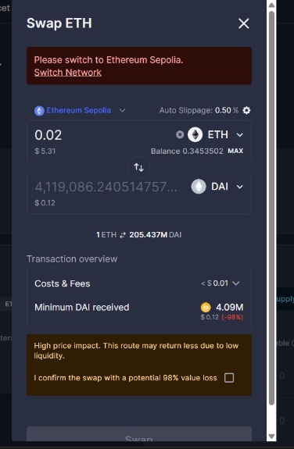 The dApp displayed a transaction overview, including a warning of "High price impact" due to low testnet liquidity. After acknowledging the potential value loss, the swap was confirmed in the MetaMask wallet.

The transaction was submitted to the Sepolia network. After a short processing time, a confirmation screen appeared, showing the swap was successful.

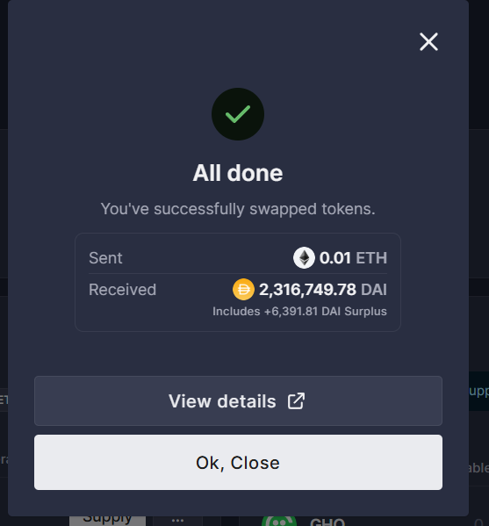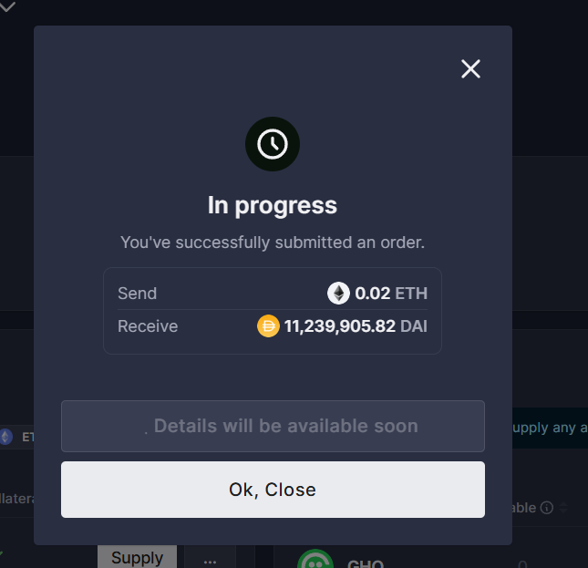

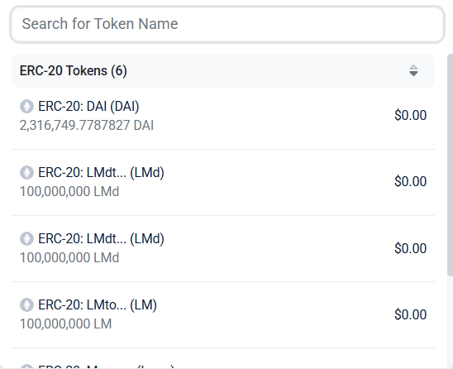

**Observation:**

The Aave dApp required enabling a specific Testnet mode and enforced a connection to the correct Sepolia network.

Low liquidity on the testnet was evident from a "High price impact" warning presented before the swap could be confirmed.

The transaction to swap 0.01 test ETH for 2,316,749.78 test DAI was successfully processed after acknowledging the warning.